PH20105 Experimental Physics & Computing 2: MATLAB assignment

Assessment part 1:

x = (20-(3-(7^(2+1i*pi*cos(pi/3))))); %1

v1 = transpose(1:10);  %2

imag(x+(2+1i)*v1(5));  %3

v2 = v1.^2;    %4

dot(v1,v2);    %5

Matrix1 = randi([2 10], 15, 10);  %6

det(Matrix1(1:10,1:10));   %7

sum(Matrix1(:)>5);      %8

max(Matrix1(:,3))       %9

plot(0: pi/100: 2*pi, sin(0:pi/100:2*pi), 'r');   %10

Matrix2 = (Matrix1(1:10,1:10))+

transpose(Matrix1(1:10,1:10));  %11

max(eig(Matrix2))  %12

trapz(2:1/1000:5, (1+(2:1/1000:5)).^2)   %13

Assessment part 2:

Electric potential and field of a pair of opposite point charges



clear variables

Q1 = 1;  %first charge in Coulombs

Q2 = -1;  %second charge in Coulombs

k = 1/(4*pi*8.85*10^-12*(1*10^-3)); %constants combined

r1 = [0,1,0];   %vector position of first charge

r2 = [0,-1,0];   %vector position of second charge

[x, y, z] = meshgrid(-4:0.1:4, -4:0.1:4, -4:0.1:4);

d1 = ((x-r1(1)).^2+(y-r1(2)).^2+(z-r1(3)).^2).^0.5;  %distance to first charge

d2 = ((x-r2(1)).^2+(y-r2(2)).^2+(z-r2(3)).^2).^0.5; %distance to second charge

V1 = (k*Q1)/d1;   %potential first charge

V2 = (k*Q2)/d2;   %potential second charge

Vexact = V1+V2;   %total electric potential

surf(x(:,:,41), y(:,:,41), Vexact(:,:,41))

hold on

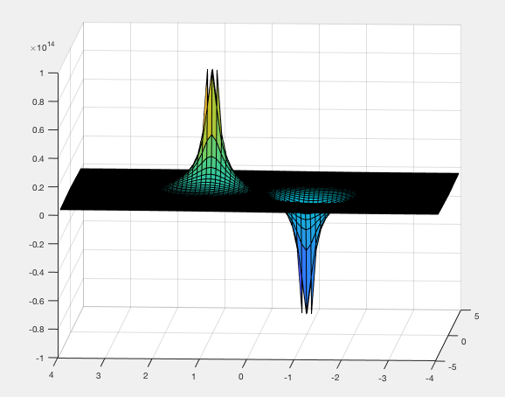

Diagram showing the surface plot of the Vexact function.



Matrix_element = ((([1, -0.8, 3.5]+4)*10)+1);

Worked out the relationship between the indices of the matrix element and the coordinates, which corresponds to +4 to account for starting at -4, x10 as the steps are 1 not 0.1 and +1 as there is an extra point due to the value at zero.



[row, col] = find(isnan(Vexact));  %gives zero therefore none

[row, col] = find(isinf(Vexact));   %gives row=31,51 (corresponds to values

%-1 and 1) col=3281, 3281 (corresponds to ???)

The first line gives none hence none of the values are ‘not a number’. The second line gives row = 31, 51. These matrix elements correspond to coordinates of -1 and 1 (working backwards using the relationship from the previous question) and col = 3281, 3281.

4.

[X, Y, Z] = meshgrid(-4.05:0.1:4.05, -4.05:0.1:4.05, -4:0.1:4);

d12 = ((X-r1(1)).^2+(Y-r1(2)).^2+(Z-r1(3)).^2).^0.5;  %distance to first charge

d22 = ((X-r2(1)).^2+(Y-r2(2)).^2+(Z-r2(3)).^2).^0.5; %distance to second charge

V12 = (k*Q1)/d12;   %potential first charge

V22 = (k*Q2)/d22;   %potential second charge

Vexact2 = V12+V22;

5.

Vapprox = k*Q1*((d22-d12)/d12*d22)

Using the electric potential (*V*) dipole equation

$V=kq(\frac{r_{-}-r_{+}}{r_{-}r_{+}}$) [1]

where k is a constant, q is the magnitude of the charge which is 1, $r_{-}$ is the distance to the negative charge and $r_{+}$ is the distance to positive charge.

6.

Difference = Vexact2 - Vapprox;

surf(X(:,:,41), Y(:,:,41), Difference(:,:,41))

Below is the plot of the difference between Vexact2 and Vapprox where Vapprox uses electric potential as given by the formula for an electric dipole.

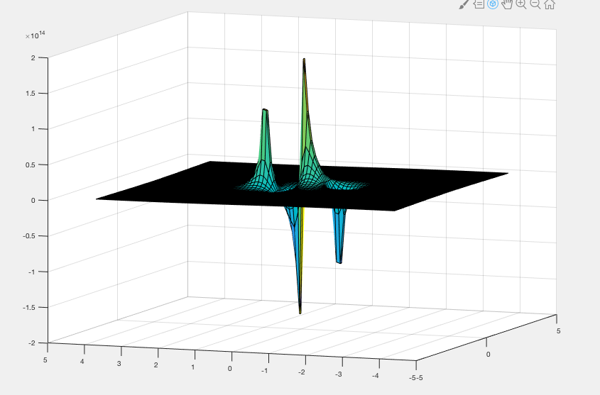

From the screenshot, it can be seen that there is a large difference between Vapprox and Vexact2 either side of the origin and another peak at the location of the charges. This implies there was little overlap between the model for Vapprox and Vexact.

One reason for the difference is that Vexact2 is inversely proportional to r whereas Vapprox is inversely proportional to r squared. In addition, the electric dipole assumes the two charges are infinitely close together whereas the electric potential equation used to find Vexact requires the superposition of two separate electric potentials.

7.

[Ex, Ey, Ez] = gradient(Vexact2);

8.

[x_, y_, z_] = meshgrid(-1.55:0.1:1.55, -1.55:0.1:1.55, -1.55:0.1:1.55);

d1_ = ((x_-r1(1)).^2+(y_-r1(2)).^2+(z_-r1(3)).^2).^0.5;  %distance

d2_ = ((x_-r2(1)).^2+(y_-r2(2)).^2+(z_-r2(3)).^2).^0.5;

V1_ = (k*Q1)/d1_;   %potential first charge

V2_ = (k*Q2)/d2_;   %potential second charge

Vexact_ = V1_+V2_;   %total electric potential

[Ex_, Ey_, Ez_] = gradient(Vexact_);

quiver(x_,y_,Ex_,Ey_, ‘red’)

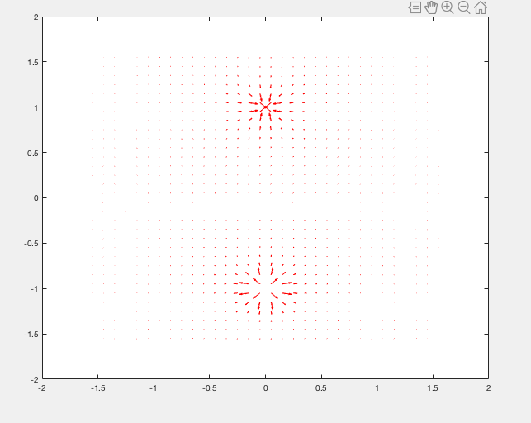

[1] http://hyperphysics.phy-astr.gsu.edu/hbase/electric/dipole.html